**UNLOCKING INSIGHTS IN THE GLOBAL AIR TRANSPORTATION NETWORK**

**INTRODUCTION:**

Unlocking in the global air transportation network refers to the process of removing barriers, enhancing connectivity, and

facilitating the efficient movement of people, goods, and services across the world through air travel. This concept encompasses a range of strategies and initiatives aimed at improving the accessibility, sustainability, and economic impact of the aviation industry on a global scale.

**EMPATHY MAP**

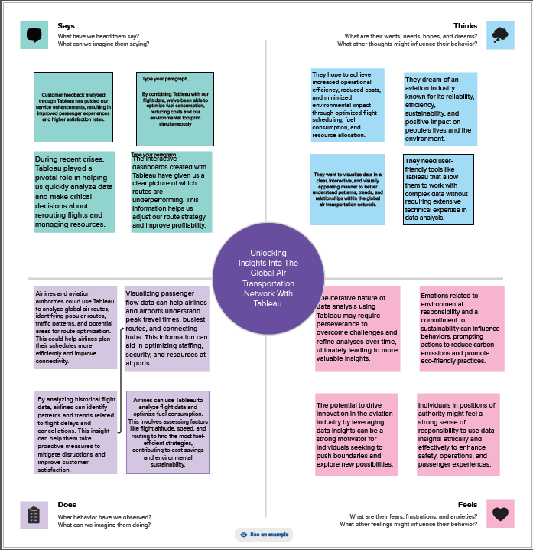

**BRAINSTORM**

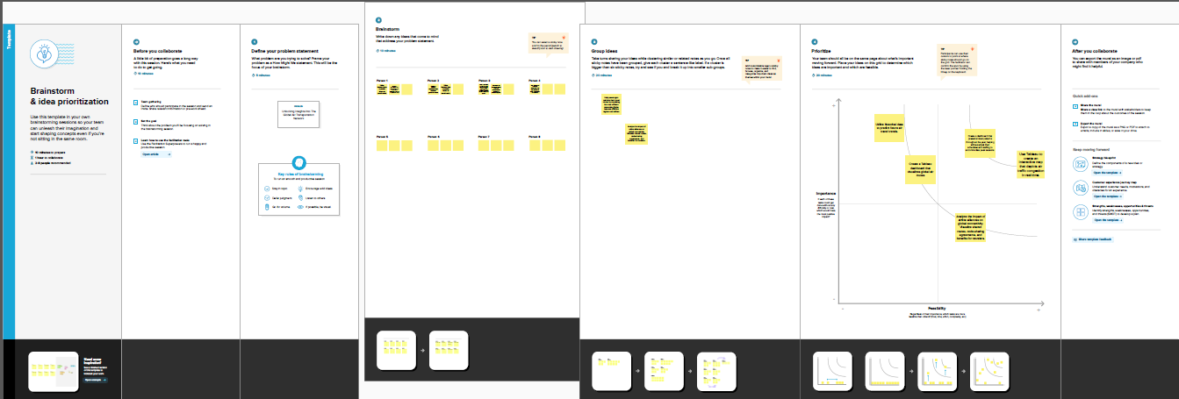

**WORLD MAP SHOWING DETAILS OF ALL AIRPORTS WITHIN A COUNTRY**

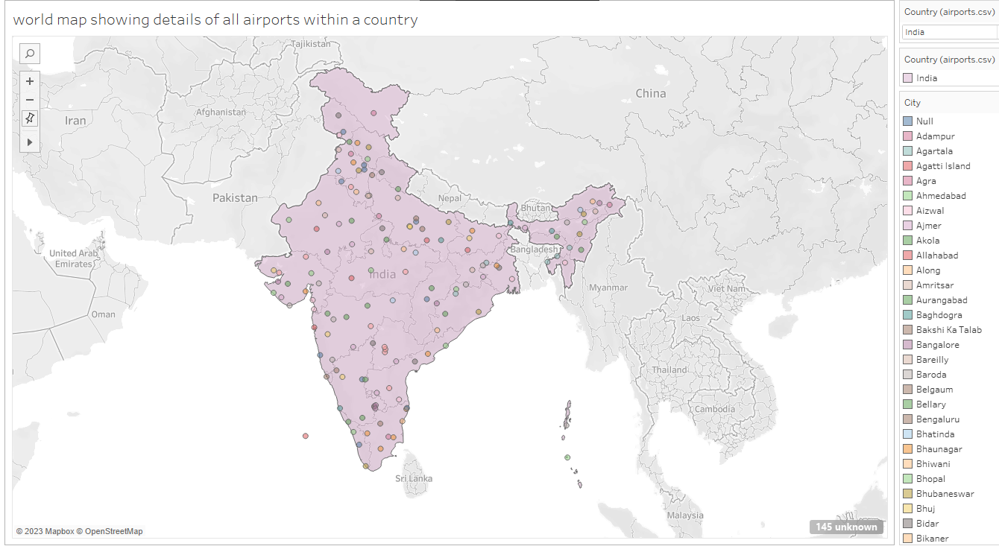

**AIRPORTS AT HIGHER ALTITUDE WITHIN A COUNTRY**

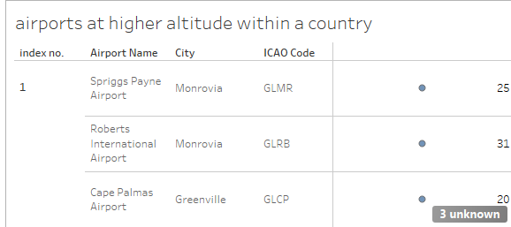

**AIRPORTS AT HIGHER ALTITUDE IN THE WORLD**

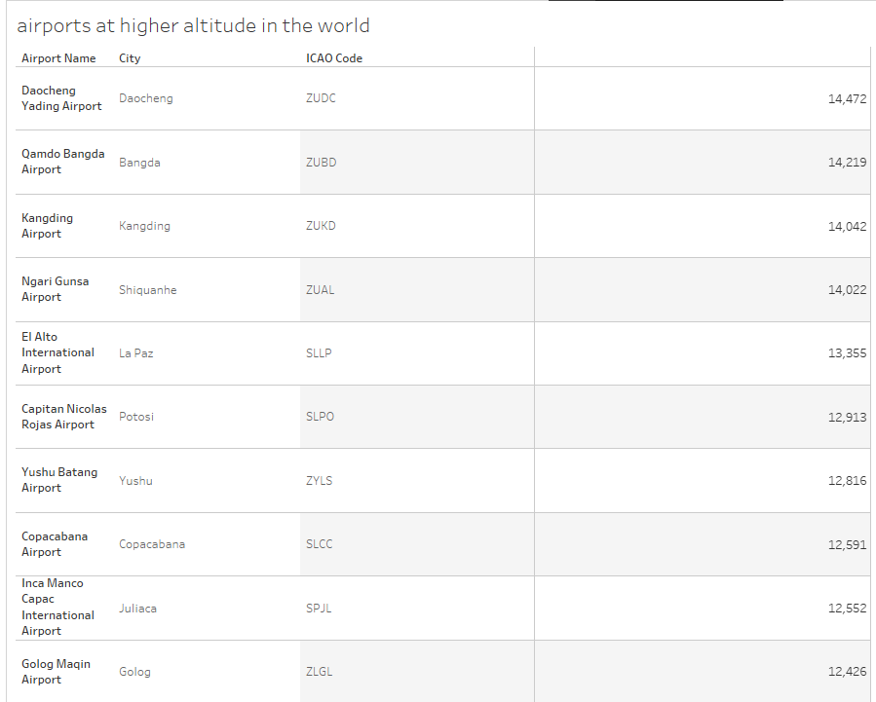

**AIRLINES WITHIN A COUNTRY**

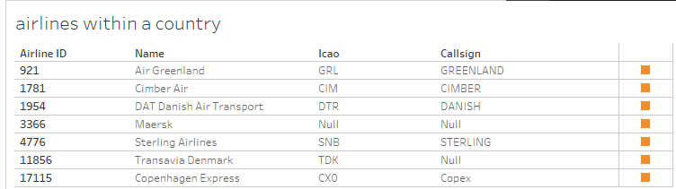

**NUMBER OF FLIGHTS FROM AIRPORT**

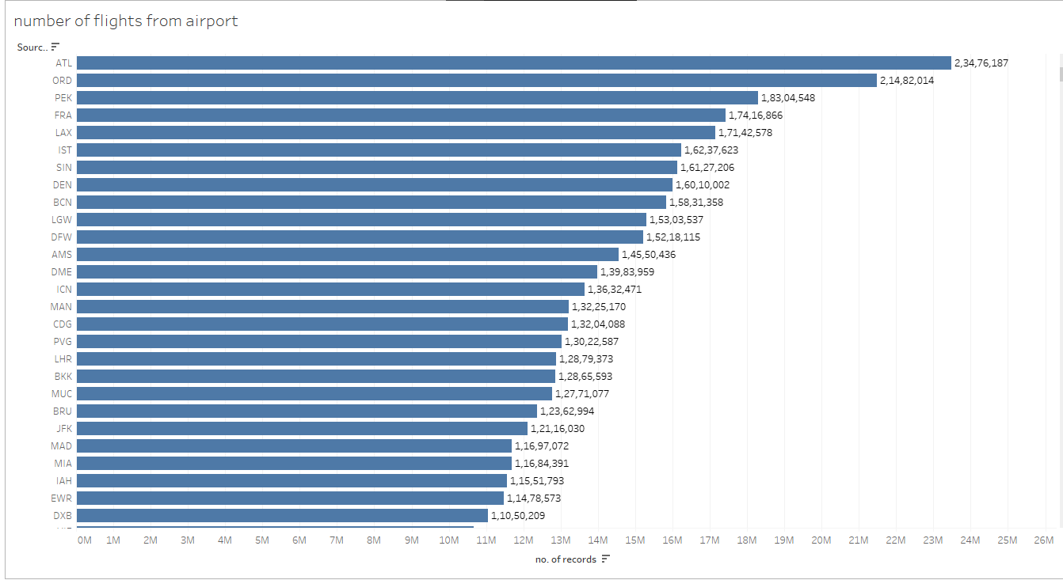

**DASHBOARD 1**

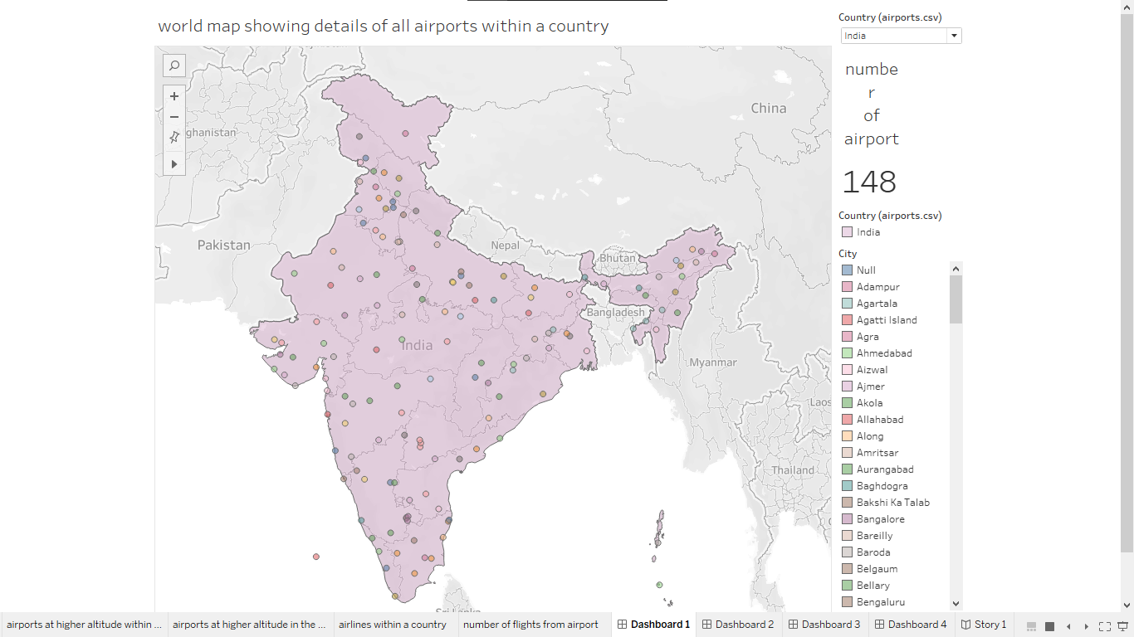

**DASHBOARD 2**

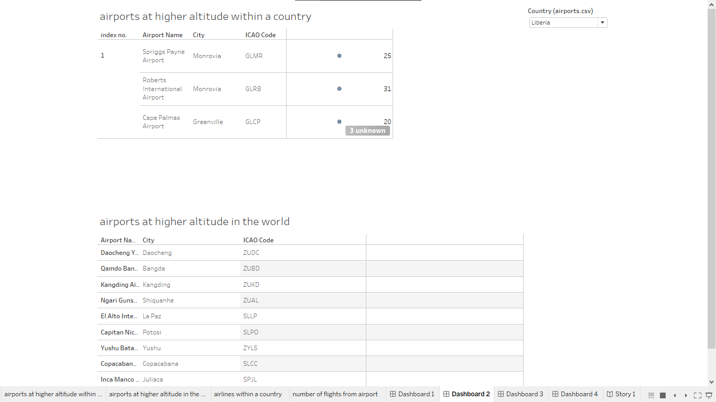

**DASHBOARD 3**

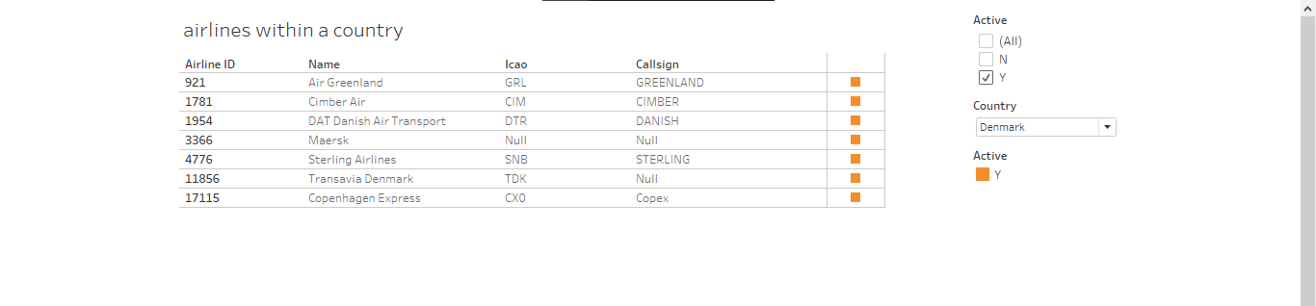

**DASHBOARD 4**

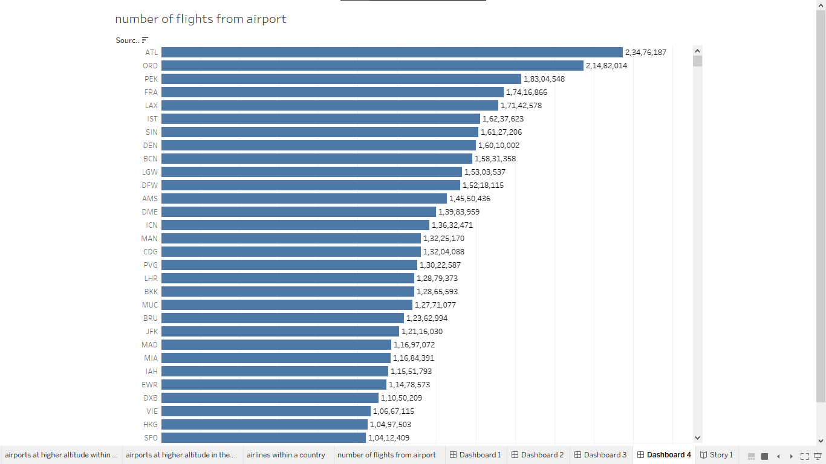

**STORY**

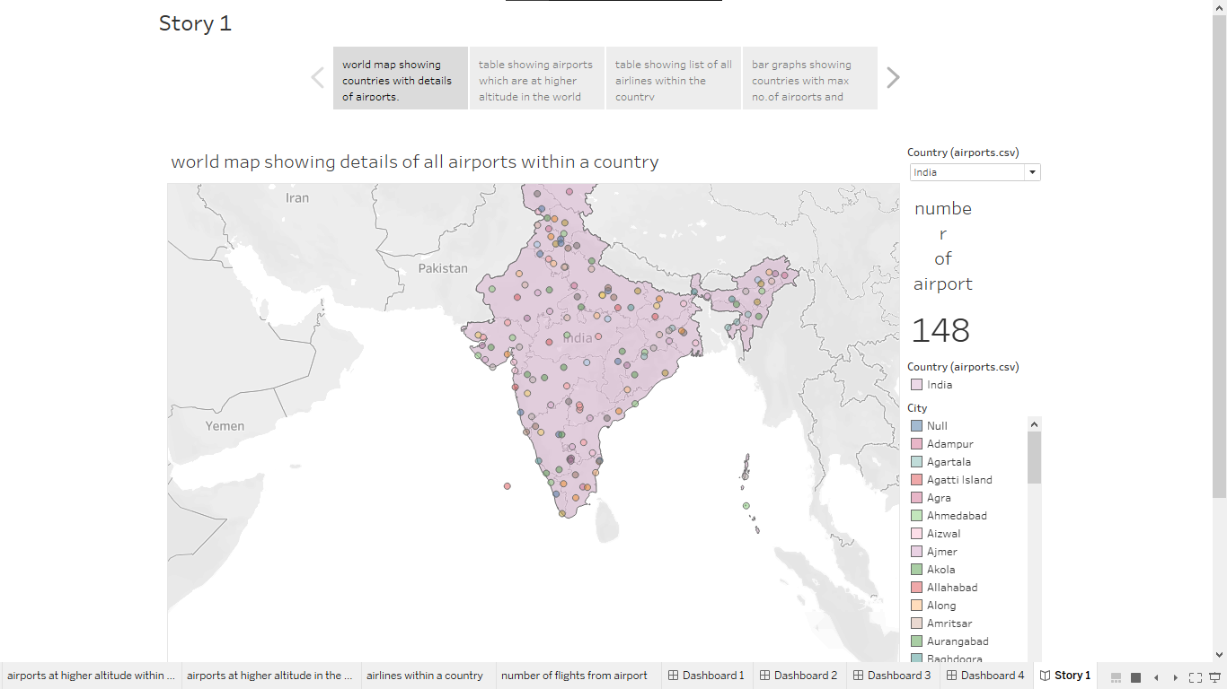

**CONCLUSION**

In essence, unlocking insights in the global air transportation network is about leveraging knowledge and technology to

create a more efficient, sustainable, and interconnected aviation industry. This not only benefits the industry itself but also contributes to global economic development, cultural exchange, and the well-being of people across the world. As we continue to unlock these insights, the sky is truly the limit for the potential of air travel in our increasingly connected world.